Template for Departmental Activity Report

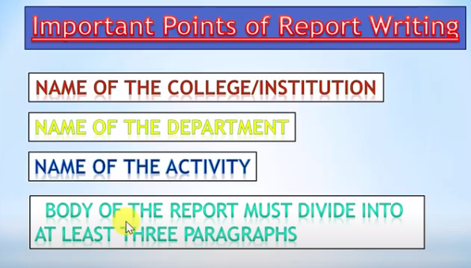
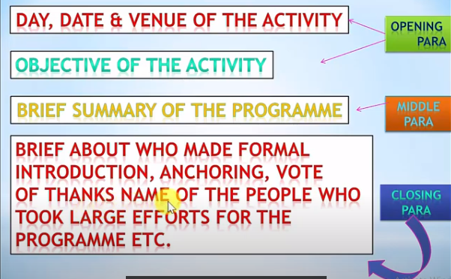
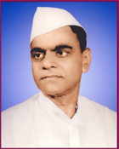
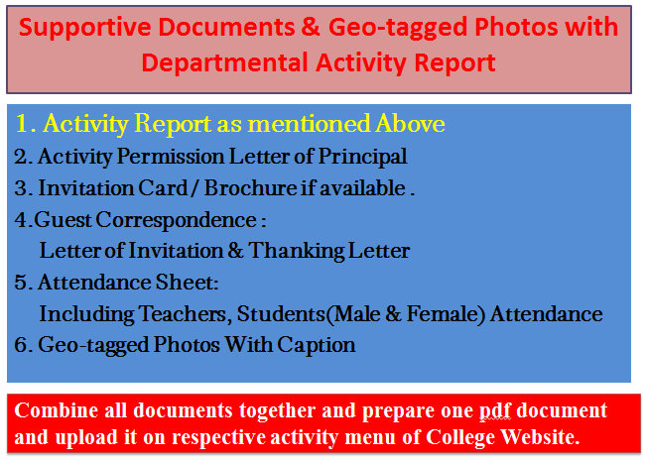
Janata Shikshan Sanstha’s
Kisan Veer Mahavidyalaya,Wai
Department of N. C. C.
Weapon Training Camp
Report
The “Weapon Training Camp” was organized by the department of NCC in collaboration with 22 MAH NCC Batalion, Satara on 28-01-2020. Special training was provided ny the Army staff with the help of various weapons and ammunitions to the NCC cadets and students. 100 cadets and 100 students participated in this camp. Mr Manoj Shinde and Mr Gajanan Jadhav, Directors of Sports helped to succeed the training camp.

College Seal
Dr. I. F. Pailwan Lieutenant Sameer Pawar
I/C Principal NCC Officer
Kisan Veer Mahavidyalay,Wai NCC Unit
2. Activity Permission Letter of Principal

Paste the PDF

4. 4.Guest Correspondence:
Letter of Invitation & Thanking Letter

Paste the PDF
3. Invitation Card / Brochure if available

Paste the PDF

Combine all documents together and prepare one pdf document and upload it on respective activity menu of College Website.
Caption
Caption
Paste the PDF
Paste the PDF
Caption
Caption
Paste the PDF
Paste the PDF
5. Geo-tagged Photos With Caption

Paste the PDF
5. Attendance Sheet:
Including Teachers, Students
(Male & Female) Attendance

